Configuring Automated SQL Server Deployment via PowerShell
- RDP to your Target Server and head over to path E:\Stage\PowerShellConfigFiles. The directory structure should look like below
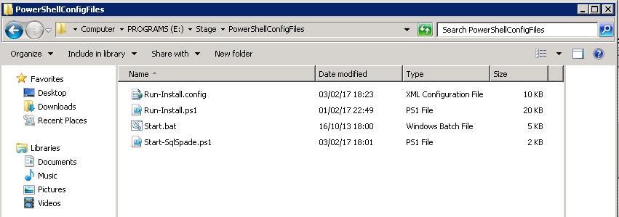

- Now go back a directory and look for SQLInstallPowerShell Folder. The directory structure will be like below
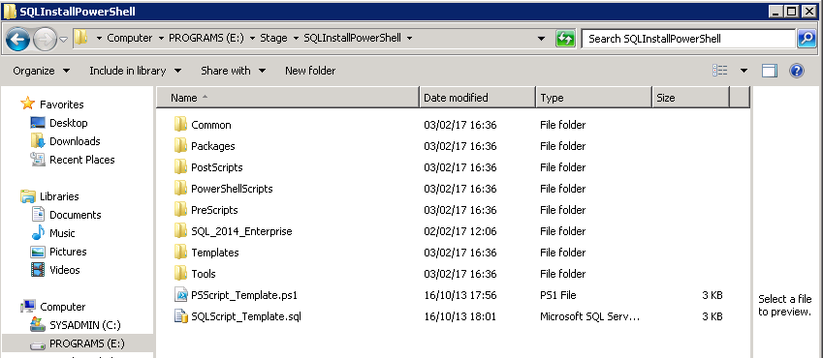

- The directory structures are exactly similar irrespective of the location, NAS or Local Storage alike.

- Now, open the “Run-Install.config”, preferably, in Visual Studio and edit the Overrides as necessary. Values to be updated are explained in the comments section in the file.
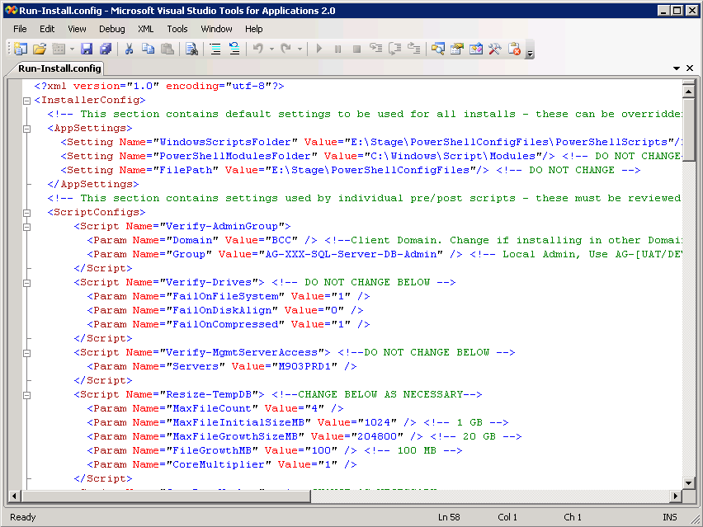

- After editing and saving the “Run-Install.config” file, execute the Start.bat file in elevated prompt.
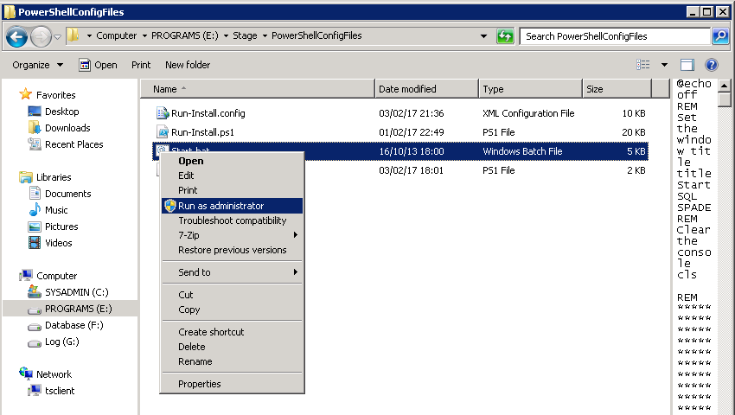
- Start.bat file invokes the PowerShell File on which the final overrides are to be placed before the installation can begin
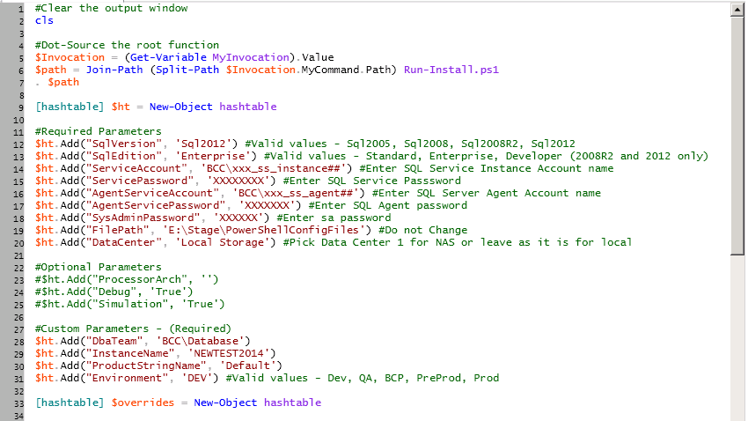

- After filling the required parameters, execute the PowerShell script and it will trigger SQL installation procedure as in the below screen
